June 12, 2013

Dear Pastor/Pastoral Administrator:

A citizen’s petition drive to initiate legislation to prohibit abortion coverage from the forthcoming health care insurance exchange is underway. This petition drive is operating under the committee name No Taxes for Abortion Insurance, and is organized by Right to Life of Michigan. The purpose for this communication is to provide additional details about the petition drive and to encourage your parish’s participation in the overall effort to gather signatures.

The Michigan Constitution allows the people to initiate legislation through a petition. In order to propose to the Michigan Legislature this prohibition on abortion coverage, approximately 258,088 valid signatures of registered voters must be gathered. Once petitions are approved by the Board of Canvassers, the Legislature has 40 calendar days to vote yes or no. If a simple majority in both chambers approves the bill, it becomes law. If either chamber fails to vote or votes “no,” the issue will be placed before the people as a ballot question in 2014.

Beginning October 1, 2013, Michigan residents will be able to purchase health insurance on the exchange for plans that are expected to provide coverage beginning January 1, 2014. The No Taxes for Abortion Insurance committee is collecting signatures this summer to prohibit abortion coverage from the state exchange as it becomes active. To date, 21 states have passed similar legislation. The Michigan proposal would also require private health plans to offer abortion coverage as an optional rider rather than an included benefit.

In order to ensure that taxpayer dollars are not used to subsidize abortion coverage on a health care exchange sold in Michigan, this petition drive must be successful. Since the campaign is an initiative proposal, churches may speak out and distribute as much material as they wish. Enclosed you will find additional information that may be of assistance to your parish. Again, please strongly consider cooperating and participating in this petition gathering process.

If you have any questions, please do not hesitate to contact Michigan Catholic Conference public policy staff at (517) 372.9310 or visit www.michigansvoice.com. This website includes a significant amount of information about the effort. With deep appreciation for your assistance and your leadership, I am

Sincerely,

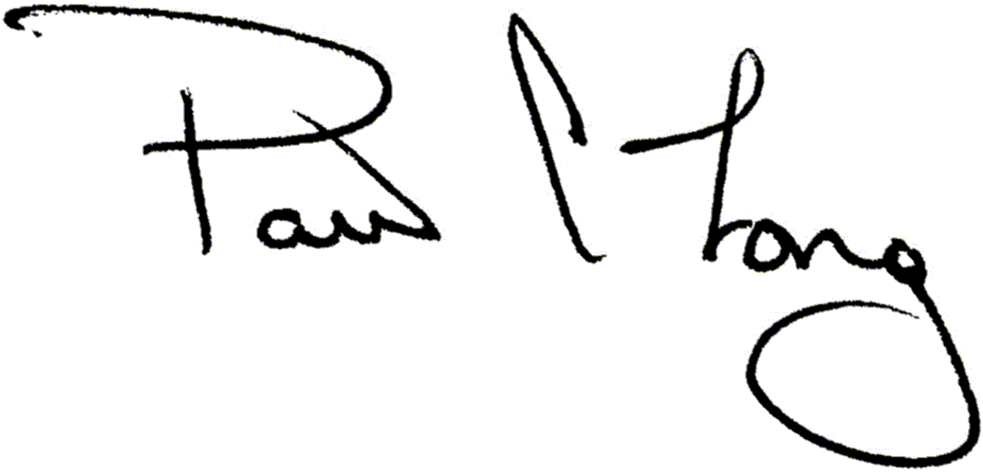

Paul A. Long
President and CEO

